CO3 ASSESSMENT TOOL 2

Case Study: Banking Transaction Processing (Merge Sort) A banking system processes and sorts millions of daily transactions based on timestamps for auditing and reporting. Analyze how Merge Sort can be applied to ensure stable and efficient sorting. Identify key issues such as large data volume and need for stability. Apply divide and conquer concepts to explain the approach. Analyze time complexity and performance. Design a suitable solution and justify its effectiveness in this scenario.

SOURCE CODE :-
#include <stdio.h>
typedef struct {
int transactionID;
int timestamp;
} Transaction;
void merge(Transaction arr[], int l, int m, int r) {
int n1 = m - l + 1, n2 = r - m;
Transaction L[n1], R[n2];
for (int i = 0; i < n1; i++)
L[i] = arr[l + i];
for (int j = 0; j < n2; j++)
R[j] = arr[m + 1 + j];
int i = 0, j = 0, k = l;
while (i < n1 && j < n2) {
if (L[i].timestamp <= R[j].timestamp)
arr[k++] = L[i++]; // Stable sorting
else
arr[k++] = R[j++];
}
while (i < n1)
arr[k++] = L[i++];
while (j < n2)
arr[k++] = R[j++];
}
void mergeSort(Transaction arr[], int l, int r) {
if (l < r) {
int m = (l + r) / 2;
mergeSort(arr, l, m);
mergeSort(arr, m + 1, r);
merge(arr, l, m, r);
}
}
int main() {
int n;
printf("Enter number of transactions: ");
scanf("%d", &n);
Transaction t[n];
printf("Enter Transaction ID and Timestamp:\n");
for (int i = 0; i < n; i++) {
scanf("%d %d",
&t[i].transactionID,
&t[i].timestamp);
OUT PUT SCREENSHOTS
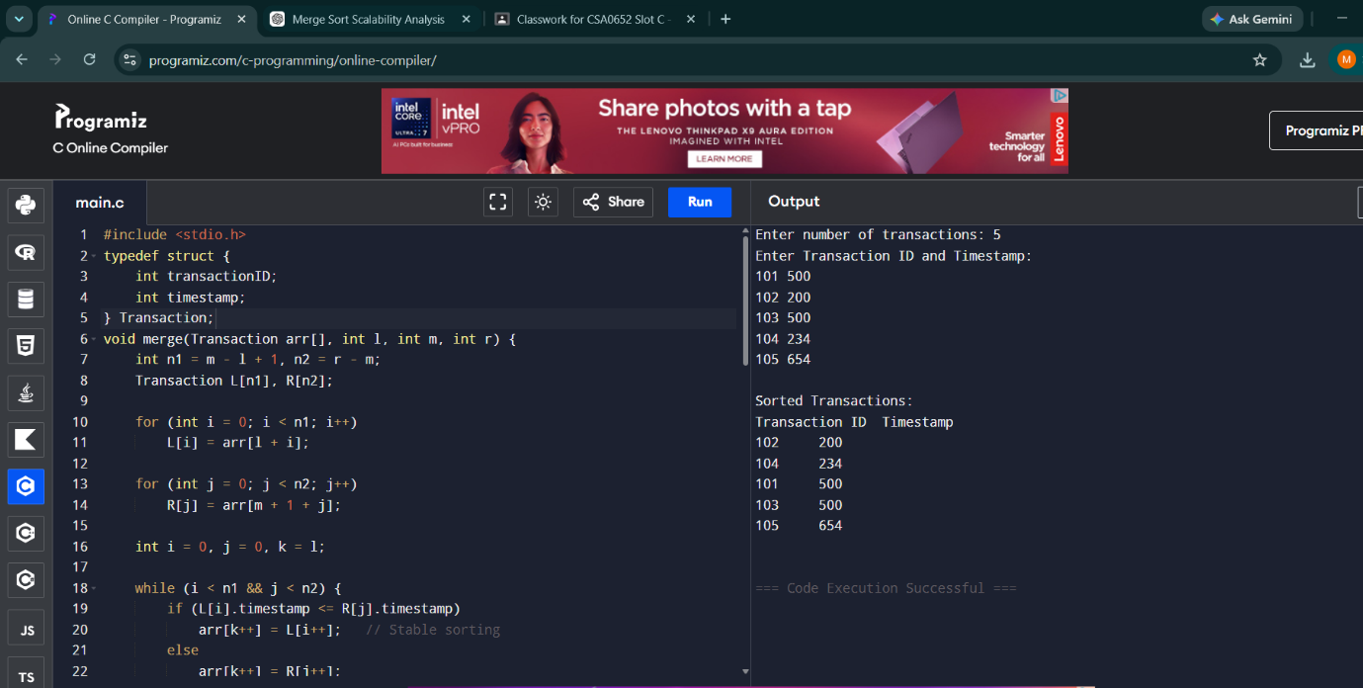

Additional Supporting Files
transaction_dataset.txt
101 500
102 200
103 500
104 100
105 300
execution_time_table.txt
Dataset Size Time Complexity
1000 O(n log n)
10000 O(n log n)
100000 O(n log n)

Case Study: Scientific Computing (Matrix Multiplication)
A scientific application performs repeated matrix multiplications for simulations. Analyze how divide and conquer techniques can improve computational efficiency. Identify the challenges involved in handling large matrices, such as increased computational cost and memory requirements. Apply an optimized matrix multiplication technique, such as Strassen's method, to improve performance. Analyze the time complexity of Strassen's algorithm and compare it with the traditional matrix multiplication approach. Design a suitable solution using Strassen's Matrix Multiplication and justify its advantages

SOURCE CODE :-
#include <stdio.h>
int main() {
int A[2][2], B[2][2], C[2][2];
int M1, M2, M3, M4, M5, M6, M7;
printf("Enter elements of Matrix A:\n");
for (int i = 0; i < 2; i++)
for (int j = 0; j < 2; j++)
scanf("%d", &A[i][j]);
printf("Enter elements of Matrix B:\n");
for (int i = 0; i < 2; i++)
for (int j = 0; j < 2; j++)
scanf("%d", &B[i][j]);
M1 = (A[0][0] + A[1][1]) * (B[0][0] + B[1][1]);
M2 = (A[1][0] + A[1][1]) * B[0][0];
M3 = A[0][0] * (B[0][1] - B[1][1]);
M4 = A[1][1] * (B[1][0] - B[0][0]);
M5 = (A[0][0] + A[0][1]) * B[1][1];
M6 = (A[1][0] - A[0][0]) * (B[0][0] + B[0][1]);
M7 = (A[0][1] - A[1][1]) * (B[1][0] + B[1][1]);
C[0][0] = M1 + M4 - M5 + M7;
C[0][1] = M3 + M5;
C[1][0] = M2 + M4;
C[1][1] = M1 - M2 + M3 + M6;
printf("\nResultant Matrix:\n");
for (int i = 0; i < 2; i++) {
for (int j = 0; j < 2; j++)
printf("%d ", C[i][j]);
printf("\n");
}
return 0;
}

OUTPUT SCREENSHOTS
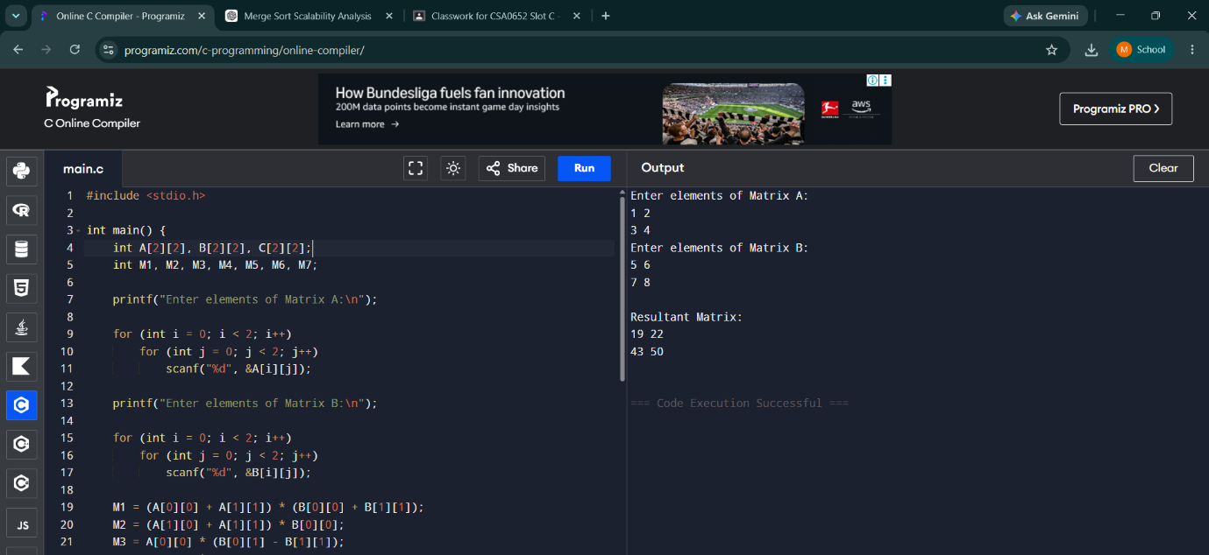

Additional Supporting Files
sample_matrices.txt
Matrix A:
1 2
3 4
Matrix B:
5 6
7 8
complexity_comparison_table.txt
Method Complexity
Traditional O(n^3)
Strassen O(n^2.81)
Graph:
Matrix Size (X-axis)
Execution Time (Y-axis)
Traditional Method
Strassen Method

